5. Design Zero-shot, One-shot, and Few-shot Prompts to Generate a Promotional Social Media Post for an AI Workshop
A. Zero-shot Prompt
Create an attractive promotional social media post for an Artificial Intelligence (AI) Workshop. Include an engaging headline, workshop benefits, a call to action, registration details as placeholders, and relevant hashtags. Use an energetic and professional tone.
Expected Output:
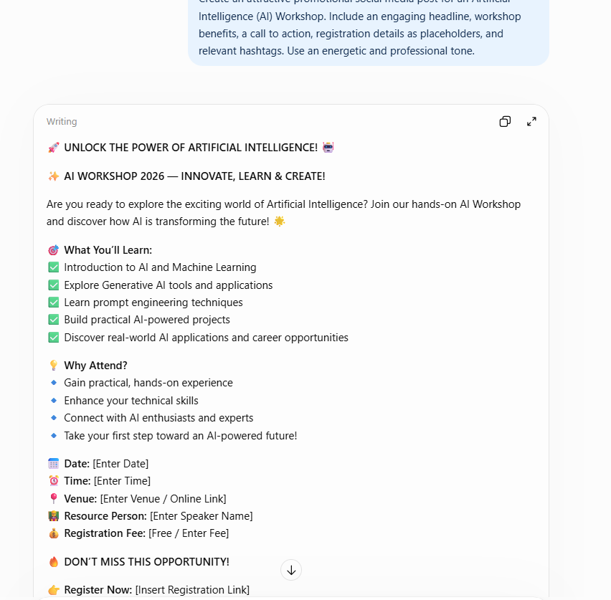
B. One-shot Prompt
Example:
🎯 Join Our Web Development Workshop!
Learn the basics of website development, explore essential tools, and discover how to create engaging websites.
📅 Date: [Date]
🔗 Register: [Link]
Start building your digital skills today!
#WebDevelopment #Workshop #LearnToCode
Now create a similar promotional social media post for an AI Workshop. Highlight AI fundamentals, practical applications, learning opportunities, registration details, and hashtags.
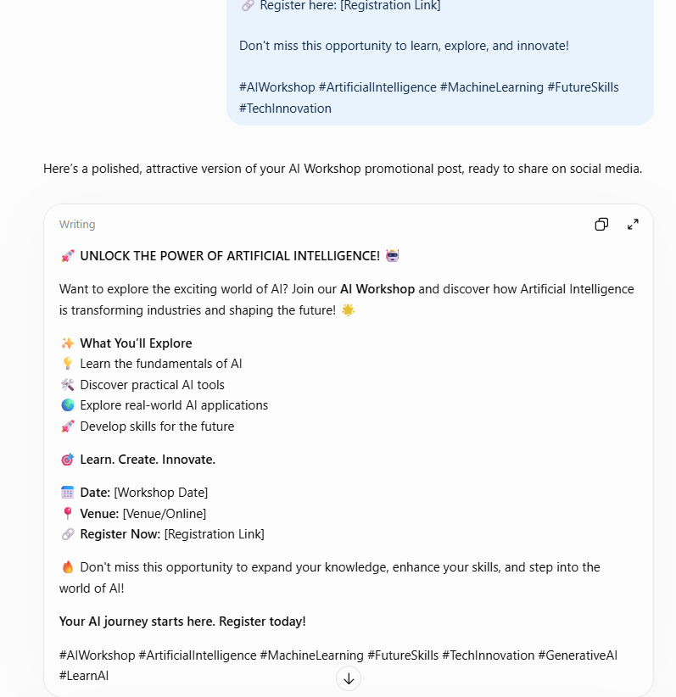
C. Few-shot Prompt
Example 1: Coding Workshop
💻 Ready to Code?
Join our Coding Workshop to explore programming fundamentals and improve your problem-solving skills.
Register: [Link]
#Coding #Programming #Workshop
Example 2: Data Science Workshop
📊 Discover the Power of Data!
Learn how data analysis helps solve real-world problems and supports better decisions.
Register: [Link]
#DataScience #Analytics #Learning
Example 3: Cybersecurity Workshop
🔐 Build Your Cybersecurity Awareness!
Explore security fundamentals and learn how to recognize common online threats.
Register: [Link]
#Cybersecurity #DigitalSafety #Workshop
Now create a promotional social media post for an AI Workshop. Use an engaging headline, highlight learning benefits and practical AI applications, include date and registration placeholders, and add relevant hashtags. Keep it concise, attractive, and professional.
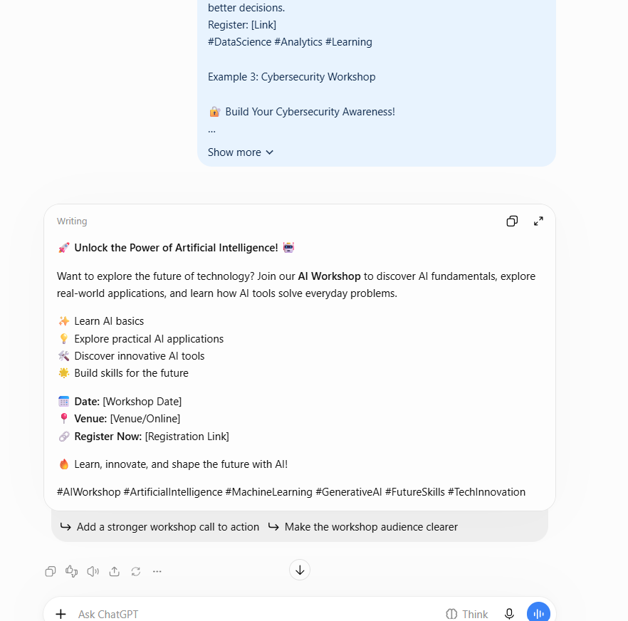
D. Comparison
Criterion | Zero-shot | One-shot | Few-shot
Creativity | Based on the instruction | Influenced by one example | Influenced by multiple examples
Tone | Specified in the prompt | Follows one post's style | Can maintain a consistent promotional style
Formatting | Generated from scratch | Uses a demonstrated format | Uses patterns across several posts
Suitability | Quick promotional content | Posts with a preferred style | Consistent promotional campaigns
Result: Zero-shot prompting is suitable for quickly creating a promotional post. One-shot prompting demonstrates the desired format, while few-shot prompting provides multiple examples to guide tone, structure, and consistency.

